**User Interface**

**Screen 1: Home Page**

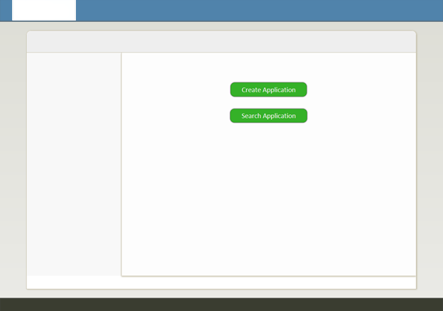

1. The home page of the application would look like above
2. When User clicks on Create application button he will be redirected to Create Application Page
3. When User Clicks on Search Application Button he will be redirected to Search Application Page

**Screen 2: Household Info**

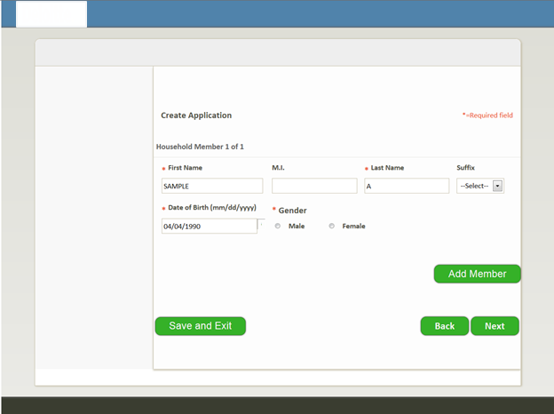

This screen allows the user to capture the Family member details and is expected to enter the head of the family as the 1st member.

     Key features of the screen:

a.      The user should be able to add 1 member at a time and can proceed to other member only after mandatory fields of the earlier member have been completed

b.      The user should be able remove an already added member

c.      User should not be able to Save & Exit after entering partial data

i.     User should be able to Save & Exit after he completes entering at-least 1 member and all mandatory checks for this member

ii.     User should NOT be able to Save & Exit if he does not enter all mandatory fields for any member on the screen

d.      If the user comes back to this screen it should be prepopulated with previously saved data

e.      Application number should be generated only after user has clicked “Save & Exit” or “Next” and when there are no validation errors.

Add Member: - When user clicks add member he would be able to add another member and additional grid containing the First Name, Last Name, MI, Suffix, DOB and Gender is populated below.

      Validation Rules

a.      Name text boxes should allow “alphabets”, special character’s “*, -, ‘“

b.      Length of name cannot be more than 32

c.      Age should be numeric and cannot be more than 125 years

d.      Age of every member should be less than the Age specified for 1st member

e.      Family cannot have more than 5 members

f. First Name, Last Name, DOB, Gender are mandatory fields.

   Navigation Rules

a.      User once he clicks “Save & Exit” should be taken to Home screen

b.      User once he clicks “Back” should be taken to Home Screen

c.      User once he clicks “Next” should result in saving of all data and user should be taken to Relationship screen

**Screen 3: Relationship Info screen**

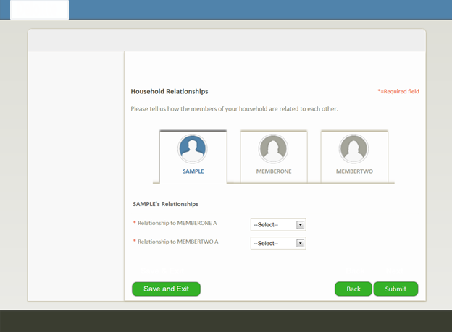

This screen allows the user to capture the relationships between the entered Family members and is used to specific relationship of each member with the other member.

  Key features of the screen:

a.      The user should be able to specify relationship of 1 member at a time add 1 member at a time and can proceed to other member only after mandatory fields of the earlier member have been completed

b.      User should be able to Save & Exit from the screen

c.      If user comes back to the screen it should be pre-populated with previously saved data

Validation Rules:

a.      Relation values are limited to “Father”, “Mother”, Son”, “Daughter”

b.      User should be able to specify relationships in the order in which the Family members are added

c.      User should not be able to click a different tab without completing the mandatory fields on the current tab

Navigation Rules:

a.      User once he clicks “Save & Exit” should be taken to Search application screen

b.      User once he clicks “Back” should be taken to Household Info screen

c.      User once he clicks “Submit” should result in data being saved and should be taken to Confirmation screen

**Screen 3: Confirmation Screen**

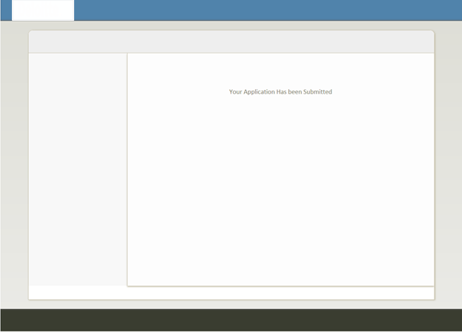

**Screen 4: Search Application**

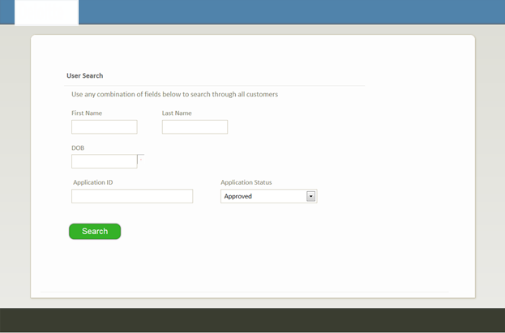

This screen allows the user to search for already submitted application to view/make changes to it.

Key features of the screen:

1. The user should be able to search by “First Name”, “Last Name”, “DOB”,  “Application ID”, “Application Status” [should act as an And search]
2. Search Functionality
   * 1. At-least 1 search condition is mandatory
     2. The user should be able see all application in the system in the form of table in bottom portion
     3. The search result should allow user to View/Edit the application in the result set

2.      Navigation Rule

    User once he clicks “View/Edit” should be taken to Household Screen for the selected Application Id

**Weekly Milestones**

**Week 1:**

1. Create project using IDE and set up the same using Maven/Gradle and create repository in bit bucket with strategy.
2. Participant will create UML diagrams such as Use Case Diagram, Class Diagram, Sequence Diagram, High Level Architecture Diagram,ER Diagram and others as applicable.
3. Identify the database entities and create corresponding tables in the database. Participant should be able to write DDL and DML. Have to submit sql files for DDL or DML.

**Week 2:**

1. Participant will set up JUNIT for the project.
2. JUNIT must be written for different scenarios.
3. BDD scenarios must be written for the stories
4. Apply design patterns and write the java code referring to the class diagram which has been created in previous week.
5. User should be able to interact with java code by giving inputs using command line.

**Week 3:**

1. Use JDBC to interact java code with database to perform CRUD operations.
2. Apply JPA features to perform CRUD operations so that participant will understand the advantages of using JPA instead of JDBC.
3. Setup logging features in the project.
4. Now replace command line interaction with JSP pages and servlets.
5. Setup project to use Spring framework.

**Week 4:**

1. Use Spring MVC concepts to replace servlets. Create model and controller classes. For view JSP’s will be used. Use different annotations of spring framework which we have learned in the session.
2. Spring Validation needs to be implemented.
3. Write the Rest Controller and application should be able to work as a rest service. Test the same using HTTP to perform CRUD operations on database.
4. Spring JPA features need to be added for interaction with database.
5. Add Spring Cloud and Netflix features so that application will work as per Micro service architecture.
6. Add Jenkins file to your application project folder.
7. Use docker to run your micro service application.

**Week 5:**

1. Create CSS file for a project and use its features which we have learned for current application.
2. Use HTML and Javascript concept and replace the JSP pages which we have created.
3. Replace front end JSP with React JS code.
4. New front end code must be able to interact with backend.